**TO DEVELOP OR DESIGN A MOBILE OR WEB APPLICATION TO CHANGE THE BACKGROUND COLOUR AND MENU**

**AIM:**

TO DEVELOP OR DESIGN A MOBILE OR WEB APPLICATION TO CHANGE THE BACKGROUND COLOUR AND MENU

**PROCEDURE:**

**1. Set Up Project:**

**- Create a project folder.**

**- Initialize with npm/yarn.**

**2. Create HTML Structure:**

**Add buttons for changing background color and toggling the menu.**

**Include a `<nav>` element for the menu.**

**3. Style with CSS:**

**- Define styles for background color and menu.**

**- Include a class to hide the menu.**

**4. Add JavaScript:**

**- Implement functions to change background color and toggle menu visibility.**

**- Attach functions to button click events.**

**Mobile Application (React Native)**

**1. Set Up Project:**

**- Initialize with `npx react-native init` command.**

**2. Create Component:**

**- Create buttons to change background color and toggle the menu.**

**- Use state to manage background color and menu visibility.**

**3. Style with StyleSheet:**

**- Define styles for background color and menu.**

**4. Implement Functionality:**

**- Implement functions to generate a random color and toggle menu visibility.**

**- Attach functions to button press events.**

**This procedure provides a high-level overview to guide the development process.**

**BEFORE**

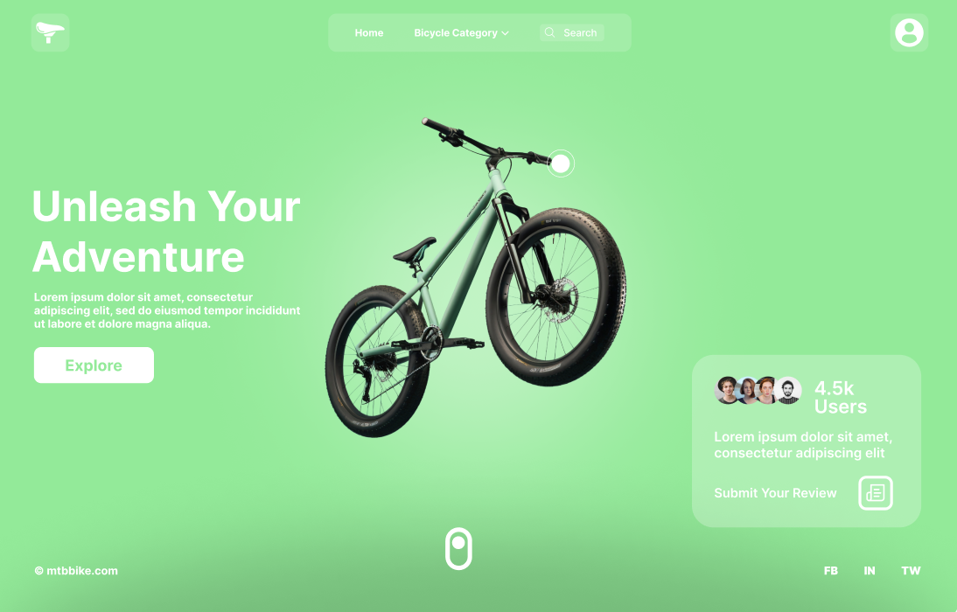

**AFTER**

